Employment Services - Administration

Purpose/Objective:

All Lead Employer Emails Signature (the sign-off at the bottom of a New message or a Reply message) should be standardised and should provide the recipient with details should they need to respond and contact the sender.
This guidance provides the how to add the signature and the content of that signature.

Version History
Version | Revision Date | Description of Change
V1.0 | 7/4/2022 | Change to the new format and update with new Website details
V2.0 | 30/6/2023 | New Trust name branding
V2.1 | 3/7/2023 | New Trust name branding
V2.2 | 8/10/2023 | New Trust name branding
V2.3 | 20/10/2023 | New Trust URL, Social Media - updated

Document Information
This is an online document. Paper copies are only valid on the day they are printed. If on review you feel updates to the document are required, please contact the Service Development team.

Document Navigation
We have utilised Word Navigation within this document which will help you to navigate around the document and reach the section you require guidance on.

To use this function, complete the following steps
- Click the “View” tab in the Ribbon.
- Check the “Navigation Pane” checkbox in the “Show” button group.

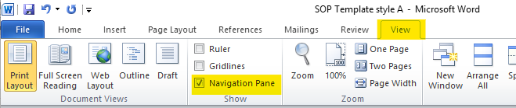
- The Navigation pane opens, by default, docked to the left side of the application window.
- You can then click on the relevant section and it will take you to the correct section of the document.

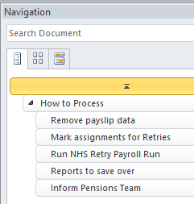

LEAD EMPLOYER GUIDANCE

Standard format for emails

The standard format for emails is:
- Font: Arial
- Size: 11
- Colour: Black

Email Signatures

- Click on ‘File’ at the top left of your screen and select ‘Options’
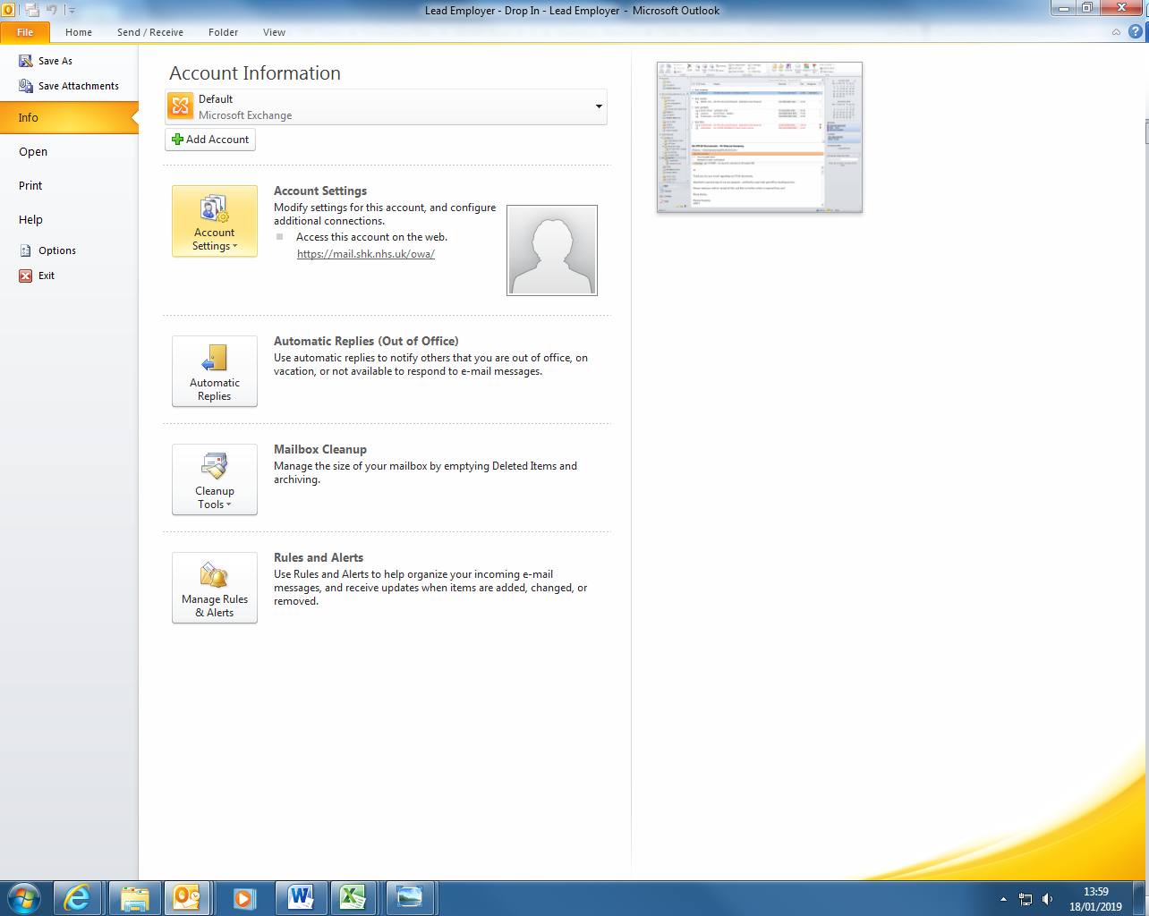

- Select ‘Mail’
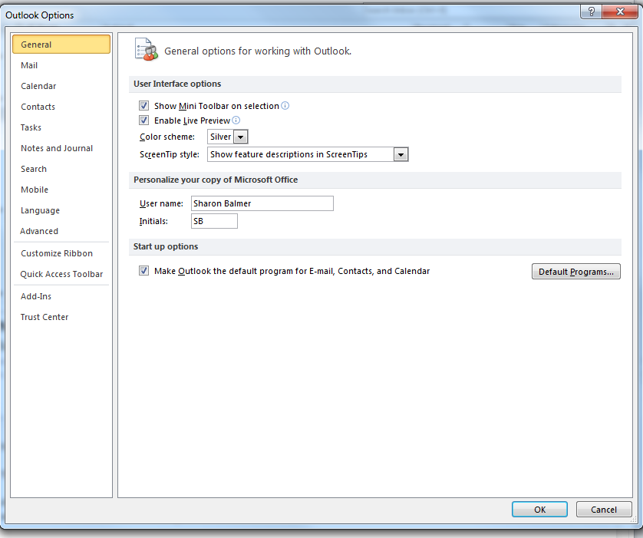
- Click on ‘Signatures’
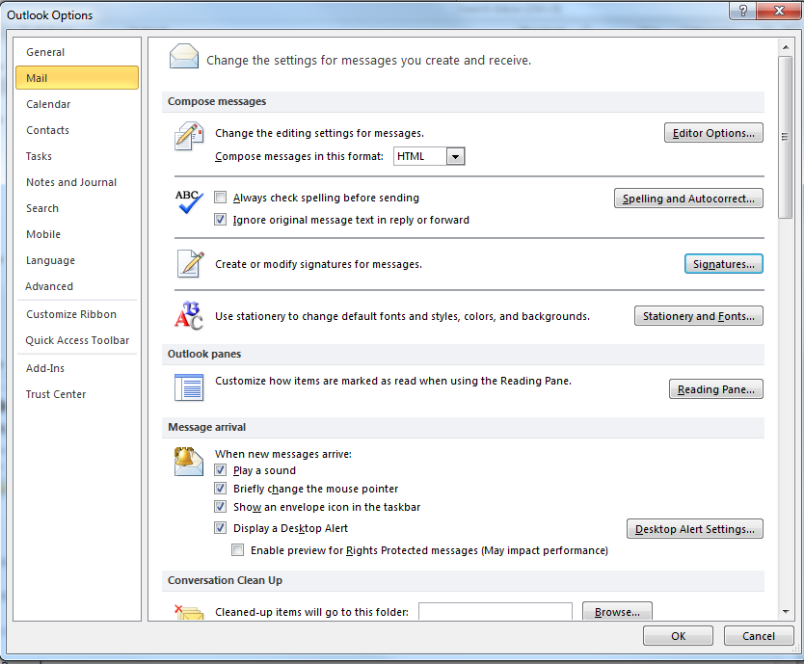

- You will need to set up two signatures: one for new messages; and the other for replies and forwards. Click on ‘New’, type a name for the signature (e.g. New Messages) and click on ‘OK’

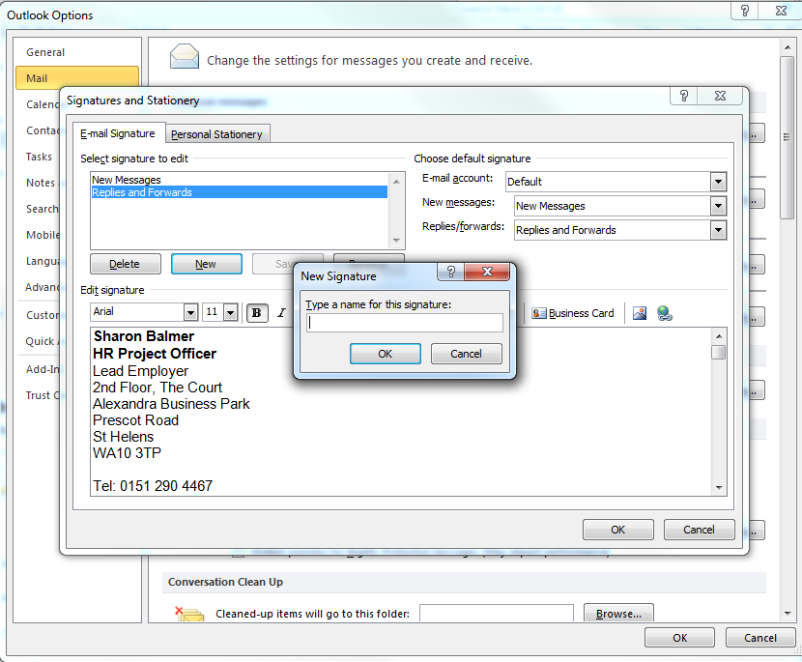

Copy and paste the format provided below for new messages into your signature and repeat the process for replies and forwards. Sections in brackets e.g. [example] should be replaced with your details with the brackets removed. The green font is guidance only and should not be copied into your signature:

  - New messages signature format

Firstname Lastname
(Pronoun)
Job title
Team

Lead Employer
2nd Floor, Jubilee Court,
Waterside,
St Helens,
Merseyside
WA9 1TT

If you work outside normal 9:00 am – 5:00 pm hours or have a non-working day – please add your work pattern. E.g.as below – do not include this red text
Normal working hours:
Monday to Thursday 08:30 - 17:30
Friday – Non-working day

Lead Employer Helpdesk Number – 0151 478 7777
Lead Employer Website: leademployer.mwl.nhs.uk
Lead Employer Communications Email: lead.employercommunications@sthk.nhs.uk

When emailing Lead Employer please include the nature of the enquiry (e.g. maternity leave) in the subject header to ensure emails are sent to the correct team.

If you are returning any personal or confidential information, it is important that you securely protect the information that you send and you should ensure that you protect any personal or confidential information held (in line with Information Sharing Agreements for Lead Employer)




Replies / Forwards signature format:
Firstname Lastname
(Pronoun)
Job title
Team

Lead Employer
2nd Floor, Jubilee Court,
Waterside,
St Helens,
Merseyside
WA9 1TT

If you work outside normal 9:00 am – 5:00 pm hours or have a non-working day – please add your work pattern. E.g.as below – do not include this red text
Normal working hours:
Monday to Thursday 08:30 - 17:30
Friday – Non-working day

Lead Employer Helpdesk Number 0151 478 7777

  - Example Team Title lines:

- Team – Lead Employer Helpdesk
- Team – On-Boarding and Data Management
- Team – Rotations and Contract Changes
- Team – Pay and Work Schedules

- To assign default signatures click on the drop-down boxes for ‘New messages’ and ‘Replies/forwards’ and select the relevant signature you have set up. Click on ‘OK’ and then ‘OK’ again.

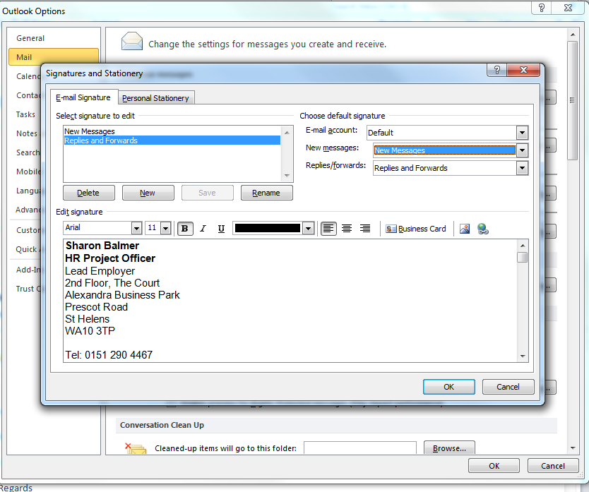

Email Salutations

Formal emails should be signed off in the following manner:
  - Name of receiver unknown:
“Dear Sir / Madam,
[Email content]
Yours faithfully,
[Signature]
  - Name of receiver known:
“Dear [Title e.g. Dr] [Name of receiver],
[Email content]
Yours sincerely,
[Signature]
Informal emails can be signed off as deemed appropriate. Examples you may use include:
- Best wishes
- Kind regards
- Many thanks

Supporting Documents

 | The following documents are available in support of the SOP

