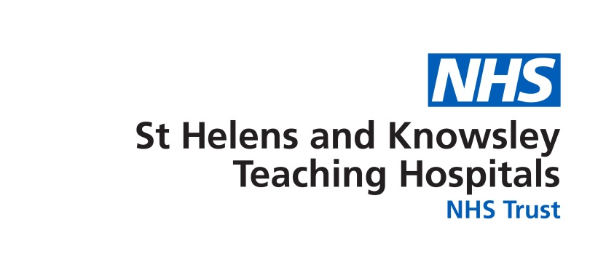

**Resolving Workplace Issues**

This form should be used to formally raise a workplace issue if you have a dispute or complaint concerning your employment. You should first ensure that you have exhausted all informal efforts to resolve your issue as outlined in the Respect and Dignity at Work policy.

|  |  |
| --- | --- |
| **Employment Details** | |
| **Name:** | **GMC/GDC Number:** |
| **Training region:** | **Specialty:** |
| **Current host organisation:** | **Current clinical/educational supervisors’ details (include full name and their email):** |

|  |
| --- |
| **Outline of Complaint –** Detail your workplace issue. Please include the following details:   * *The host organisation and department where your concerns arose* * *The dates and times of incidents and names of witnesses where appropriate,* * *Factual descriptions of events, including direct quotations where available* * *How the incident made you feel* * *An explanation of why you consider the behaviour constitutes harassment, bullying, discrimination or victimisation* |
|  |
| **Informal Action Taken -** Describe the informal undertaken taken to resolve the issue and any outcome(s).    *Please include information around any meetings you may have attended including dates, names and job titles of those in attendance. You should also confirm what action was taken following informal resolution and any support that you may have received.*  *Examples of informal resolutions are outlined below. Please see* ***Appendix 1*** *for a summary of each.*   * *Facilitated Conversation* * *Restorative Practice* * *Mediation*   *Have you given consideration to these resolutions and have they been offered to you in order to resolve your concerns?*  *Yes / No* |
|  |
| **Outcome Sought** - Detail the outcome(s) that you are seeking as a resolution to your workplace issue. Please note that you cannot request that another colleague be disciplined or dismissed. |
|  |
| ***PLEASE NOTE THAT THIS FORM SHOULD BE PERSONALLY SIGNED BY THE INDIVIDUAL RAISING THE REQUEST***  ***Signed:*** *…………………………….…………….*  ***Date:***  *…………………………………………..* |

**Appendix 1 - Examples of informal Resolution**

**Facilitated Conversation**

A facilitated conversation is a more in-depth resolution process which is considered to be highly effective at resolving issues at an informal stage. It will be used where an informal Resolution Manager feels that a conversation involving advice from a trained facilitator (this will usually be somebody from within the Lead Employer, the Host Organisation or HEE) would benefit the parties involved. If the issue is being dealt with under the informal process, all parties must agree to take part in a facilitated conversation before the issue / concern is discussed with a member of the HR team.

The facilitated conversation process is supported by the HR team member and involves;

* Having separate preliminary phones calls with both the manager and the colleague to explain the principles and processes of a facilitated conversation and get their initial thoughts on the issues
* Arranging and conducting a facilitated face to face meeting
* Facilitating an agreement between the manager and colleague and recording this in an informal resolution agreement

A facilitated conversation is usually completed in a couple of hours however, it may take longer if more than two people are involved.

The member of the HR team, as a facilitator, will help the parties have an open and honest dialogue with the aim of identifying an outcome that is agreed by both parties. If needs be, the facilitated conversation can be paused to discuss aspects with just one or other of the parties if it is thought this will benefit a positive outcome of the meeting. If this is the case, the facilitator will encourage parties to sign up to an informal resolutions agreement.

Whilst facilitation and mediation remain voluntary, they are proven to be highly effective. The Trust expects colleague/managers to give these processes serious consideration and not to rule them out without good reason.

**Restorative Practice**

Restorative practice can be used within the workplace both to prevent conflict resulting in inappropriate behaviour at work, damage to workplace or team relationships, and to address it when it does occur, enabling teams and individuals to work well together.

Where situations have already arisen – for example in cases where allegations of disrespectful behaviour, emotional and verbal abuse, intimidation or bullying feature in the grievance, restorative practice can be an effective way to resolve these issues without recourse to formal processes.

It involves:

* bringing together all those affected by conflict
* providing a safe environment for the expression of emotion
* allowing participants to come to a shared understanding
* identifying creative ways to deal with conflict
* providing opportunities to rebuild damaged relationships and strengthen teams

Restorative approaches can also be used proactively and in a preventative way within the workplace to build strong, positive relationships. Staff meetings, for example, can be restorative practice, focused on building relationships and based around a foundation of mutual respect.

While processes such as workplace mediation generally have a fairly narrow focus on a particular conflict and its resolution, restorative practice has a wider focus and aims to build better relationships and a stronger community. This allows everyone involved to find a positive way forward.

**Mediation**

Mediation is a more in-depth resolution process which is proven to be highly effective at resolving workplace disputes, disagreements, complaints or concerns. If all parties agree to take part in mediation, the aggrieved colleague’s issue will be referred to one of the Trust’s internal accredited mediators. The mediator will contact both parties by phone and explain the principles and processes of mediation. The mediation process includes:

* Separate initial phone calls for each party with the mediator(s) to explain the principles and process and address any queries or concerns
* Separate meetings for each party with the mediator(s) to discuss the substantive issues
* A face to face meeting between the parties facilitated by the mediator
* Reaching agreement and closing the meeting

Most mediation will be completed in a day; it may take longer if more than two people / parties are involved. Mediation is a voluntary and confidential process.

The mediator will help the parties have an open and honest dialogue with the aim of identifying a mutually acceptable outcome. If this is the case, the mediator will encourage parties to draw up an agreement.

After mediation has finished the aggrieved colleague may agree that, if appropriate, others can receive a copy of the final written agreement. However, the Trust will not receive any other feedback from the mediator about issues raised and discussed or any other factors raised during the mediation process however, will feedback to the relevant parties if the mediation was successful or not.