

Culture Shock

Culture shock refers to the feeling of disorientation and discomfort experienced by individuals when they encounter unfamiliar cultural norms, values, customs, and behaviours in a new or different cultural environment.

It is a common experience that can occur when people travel or move to a different country or even when they encounter diverse cultural groups within their own country.

Culture shock typically involves several stages:

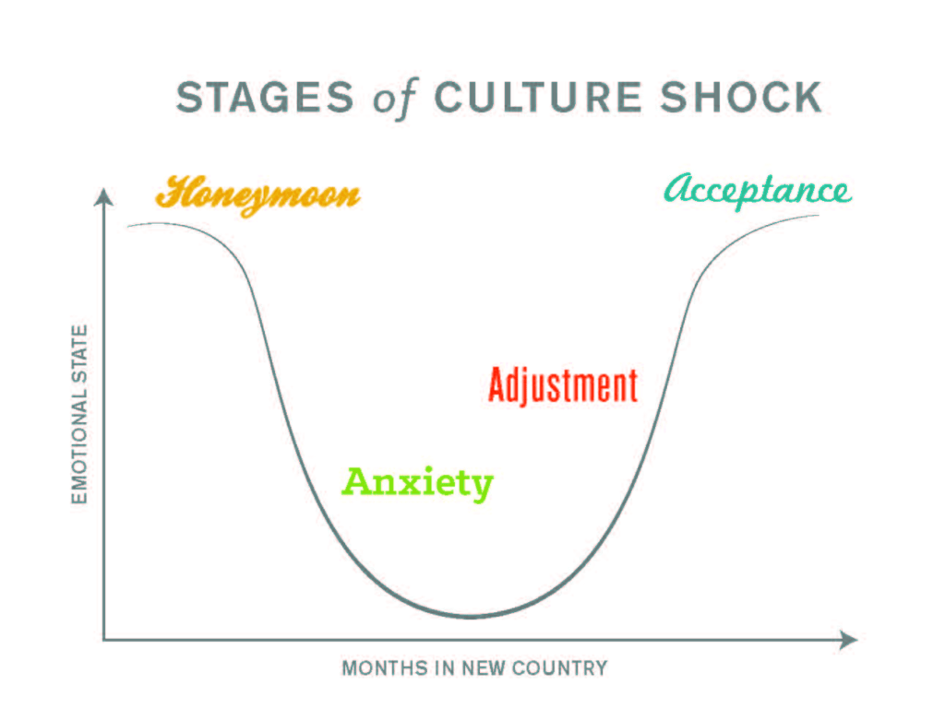

1. **Honeymoon Stage**: Initially, individuals may experience excitement and fascination with the new culture. Everything seems fresh and interesting.
2. **Frustration Stage**: As the initial excitement fades, individuals may start to experience frustration, anxiety, and confusion. Differences in language, communication styles, social norms, and daily routines can become apparent and challenging to navigate.
3. **Adjustment Stage**: Over time, individuals begin to adapt and adjust to the new culture. They develop coping mechanisms, learn the language, understand social norms, and establish routines.
4. **Acceptance Stage**: In this stage, individuals become more comfortable and accepting of the new culture. They may develop friendships, feel a sense of belonging, and appreciate the unique aspects of the culture.

It's important to note that culture shock is a personal and subjective experience, and individuals may go through these stages at different paces.

While culture shock can be challenging, it can also provide opportunities for personal growth, increased cultural awareness, and the development of cross-cultural competencies.

To cope with culture shock, it can be helpful to:

* Educate yourself about the new culture before arrival.
* Maintain an open and curious mindset.
* Seek support from locals, expatriate communities, or support groups.
* Learn the local language or at least some basic phrases.
* Engage in cultural activities and immerse yourself in local customs.
* Take care of your physical and mental well-being.
* Stay connected with family and friends back home.
* Give yourself time and be patient with the adjustment process.

By actively engaging with the new culture, seeking support, and maintaining a positive attitude, individuals can navigate the challenges of culture shock and ultimately embrace the richness and diversity of their new cultural environment.